Welcome to the 2026 Taste of Beaufort!

The City of Beaufort is proud to host the 2026 Taste of Beaufort on Friday, May 1st from 5pm to 10pm, and Saturday, May 2nd from 11am to 4pm at Henry C. Chambers Waterfront Park.

Friday evening features a live concert and Art & Craft Market. Saturday offers live music throughout the day, Art & Craft Market, and a Kids' Corner with activities for children.

We invite Beaufort's restaurants to participate by offering samplings of your cuisine. This is an excellent opportunity to gain visibility, connect with the community, and showcase what makes your establishment special.

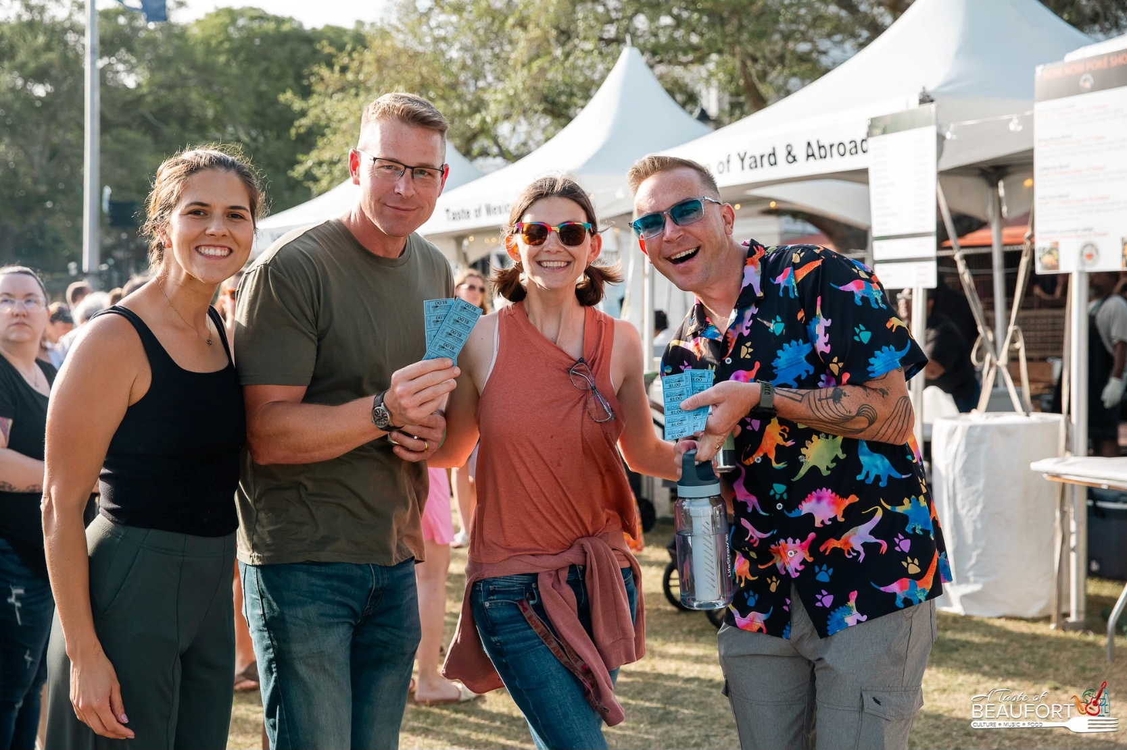

RULES & REGS
APPLICATION & ELIGIBILITY. Applications are open to Restaurants and Food Service Vendors operating year-round. All applicants must have current applicable licenses and permits.
First consideration will be given to past participants. Space is limited. Completion of application does not guarantee acceptance. Applicants will be notified within 1-7 business days of receiving the completed application. The City of Beaufort reserve the right to refuse Vendors for any reason.
PAYMENT/FEES. A minimum participation fee of $500 is due with submission of application and is non-refundable if accepted into the event. Each Vendor is also required to remit 15% of gross ticket sales up to $10,000. Amount will be determined at the end of the event and due at a later date (See Redemption of Tickets, Pg. 2). The $500 fee will not be processed until your application for participation is approved. An additional 10X10 space may be purchased for and addition $300 but is subject to space availability.
Checks should be made payable to: City of Beaufort (please put in the subject line: 2026 Taste of Beaufort). Completed applications and minimum fee(s) should be remitted in person to the City of Beaufort’s Downtown Operations Office at 500 Carteret St, Ste B2, or by mail to: 500 Carteret St, Ste B2, Beaufort, SC 29902.

Booth spaces are restricted to the sale and preparation of prepared food and approved beverages.
(See Beverage Sales below.)

Booth space may not be shared with any other business or organization.

REFUND POLICY. All funds collected are for the production, promotion, marketing, and advertising of the 2026 Taste of Beaufort. Refunds are not available. In the event that the festival is canceled, every effort will be made to reschedule.
MANDATORY PRE-EVENT MEETING. All food and beverage Vendors are required to attend a pre-event meeting with event organizers, City staff and contractors. This meeting is mandatory and failure to send a representative could result in your forfeit of participation in this and future events with no refund of your fee. This meeting will be held on Friday, April 24, from 9am to 11am on-site at the Henry C. Chambers Park, Waterfront Pavilion. An email invitation will be sent up on approval of application.
BEVERAGE SALES. The City of Beaufort is engaging a partner to supply all non-alcoholic beverages. Through this partnership, Food Vendors will be able to acquire, at a reduced cost, beverages by the case (coke, diet coke, sprint, and water), for individual sale during the event at their booth space. Price to patrons will be set by the festival coordinator. Tickets collected by the Food Vendor for Beverage sales will be redeemed in the same fashion as food vending tickets. Non-alcoholic beverages will also be available for purchase at separate concession stand location in the food vending area. There will be beer and wine sold in two locations in the park. Ice will be provided for coolers.
TICKET SALES. Food and beverages are purchased with tickets that are sold by the City of Beaufort specifically for this event. All other tickets will not be accepted. Official ticket colors will be chosen for the event and will be shared with Vendors at the Mandatory Pre-Event meeting. Participating Vendors will only be able to redeem approved tickets.

REDEMPTION OF TICKETS. Instructions for redemption of tickets will be given at the Mandatory Pre-Event meeting on April 24. Please note that Vendors will be paid 85% of the tickets they redeem for all sales up to $10,000. For all sales over $10,000, Vendors will receive 100% of the gross sales.
FOOD PORTIONS & PRICING. All Food Vendors should serve a variety of dishes which represent the Vendor’s cuisine. Portion sizes should be limited to allow the guests to sample a variety of foods and to allow your supplies to last the required timeframe. Mandatory: one to two items must be sold for three to five (3-5) tickets. Food Vendors should serve “tastes” and NOT meals. Sides should be sold as separate items. Note: Past events have shown attendance of 6,000 to 8,000 persons.
LICENSING. The City of Beaufort will apply for all Department of Agriculture Health forms. This is done two-weeks prior to the event. If the City is notified of an issue with a Vendor’s license or permit, that Vendor will not be allowed to participate in the event and will not receive a refund of their application fee(s). Note: All Vendors must have a valid business license; and must display their health permit during the event.
WHAT WE WILL PROVIDE. The following items are Included with your application fee, unless otherwise stated: one
(1) 10 X 10-foot approved tent, one (1) Strip light, one (1) carpet, two (2) eight-foot tables, disposable tablecloths, an additional 5 feet behind your tent for cooking. Access to electricity. Ice will be available for coolers.
WHAT FOOD VENDOR WILL PROVIDE. Vendor is responsible for providing all cooking materials, products, cooking utensils, serving utensils, napkins, plates, forks, spoons, etc. Vendor is also responsible for providing staff to manage booth, and serve customers, and collect tickets. Vendor is also responsible for providing fire extinguisher; Commercial Grade Electrical Cord(s); and plywood to be placed underneath cooking space. (See Health, Safety & Fire, Pg. 4, for details). Note: FOOD TRUCKS ARE NOT ALLOWED INTO THE WATERFRONT PARK.
BOOTH OPERATION TIMES
Friday Night: Food Booths will operate from 5pm to 9:30pm Take-down may begin at 10:00 p.m. Note: Friday night Vendors participating in the event on Saturday, may keep nonfood/nonperishable items, equipment, in your tent over-night, at your own risk. The Beaufort Police Department will be on patrol. However, the City and its partners will not be responsible for any lost, damaged or stolen items. ALL PILOT LIGHTS ARE TO BE TURNED OFF.
Saturday: Food Booths will operate from 11am to 4pm. Take-down may begin at 4pm.

ALL VENDORS ARE REQUIRED TO OPERATE THEIR BOOTH FOR THE DURATION OF THE FESTIVAL.

SETUP LOCATION & TIMES. Booth locations will be provided at the Mandatory Pre-Event Meeting. At that time, Food Vendors will also sign up for load-in times.
Friday Night Vendors will be allowed to set-up between 11am and 4pm. Set-up on Friday MUST be COMPLETED by 4pm.
Saturday Vendors will be allowed to set-up between 8am and 10pm. Set-up on Saturday MUST be COMPLETED by 10am.
UNLOADING. CHECK IN AT THE VOLUNTEER CHECK IN TABLE UPON YOUR ARRIVAL TO MAKE SURE YOUR BOOTH LOCATION HAS NOT CHANGED. All items are to be unloaded neatly and quickly and loading zones should be cleared in a timely manner. Vendors are required to have all items on site before set-up. DRIVING IN THE PARK IS ABSOLUTELY PROHIBITED. Note: Load-in assignments will be made at the Mandatory Pre-Event Meeting.
INSPECTION. VENDORS MUST BE FULLY SET-UP ONE (1) HOUR BEFORE THE EVENT BEGINS. At that time, the Fire
Department and Department of Agriculture Health Inspector will arrive to inspect each booth. Vendors must display health permit.
PARKING. Parking for restaurants delivery vehicles will be provided in the vacant lot at North and Bladen, adjacent to the Santa Elena History Center. This area is only for parking your delivery vehicles. Staff/Servers parking downtown are responsible for observing all City parking regulations. Reserved parking closer to the event venue may be purchased by calling Park Beaufort at 843-379-9330.
ELECTRIC/PROPANE. For Vendors needing electric access, the City of Beaufort will supply access to electric for all Vendors. Vendors must supply their own extension cords – 50-foot in length, commercial grade. If 220v is required, please notify event coordinator as soon as possible if arrangements need to be made.
For Vendors using Propane, pilot lights must be turned off at the end of shift/day/event.
HEALTH, SAFETY & FIRE. All Food Vendors MUST provide plywood to be placed under cooking equipment outside of your tent. The ground should be fully covered. The City of Beaufort will provide carpet for the ground space underneath each tent.
All Food Vendors MUST supply a fire extinguisher – minimum size of 2A 40 BC. Vendors cooking with grease, are required to have a Class K-rated fire extinguisher in addition to the regular extinguisher (minimum size of 2A 40 BC); and OSHA approved containers for the disposal of cooking grease. (IFC 904.11.5) Containers MUST have a secure lid.
Extension Cords must be commercial grade and 50-foot in length and must be secured to prevent trip hazards.
Open flames, smoking and cooking is NOT permitted underneath a tent or membrane structure unless labeled as fire retardant. All such activity MUST be kept at a distance no less than 20 feet IFC 3104.7. Hay, Straw, and shavings are NOT located inside any tent or membrane structure. No smoking or open flames permitted under or inside a tent or membrane structure. (IFC 3104. 6-7)

TRASH/RECYCLABLES. Each restaurant is responsible for disposing of all trash generated through their food service. Capital Waste will supply recycling bins for all cans, bottles, cardboard, and paper products. Each Food Vendor will be responsible to safely (no spillage) cart materials to the bins and/or other disposal locations. Bins will be located at the compactor enclosure in the Marina Parking Lot.
GREASE/DIRTY WATER DISPOSAL. Each Food Vendor is responsible for disposing of grease and dirty water generated from your booth. ALL grease, dirty water and cooking materials are to be removed by the Vendor and disposed of properly off site. NO grease, dirty water or other products produced through cooking may be discarded in the road, gutters, drains, downtown, or festival trash cans, or other permanent infrastructure in downtown Beaufort including mulch beds and grass. Anyone found doing this will be responsible for any and all environmental cleanup costs and subject to prosecution by the City of Beaufort and/or State and Federal entities. The Greenery, Inc. will be on hand to direct proper disposal of dirty water and clean water.
CLEAN WATER DISPOSAL. If you have clean water (water you would drink) to dispose of, a representative from The Greenery, Inc. will be on hand and can instruct you of where you can discard it. DO NOT dump even clean water on the grass.
BREAKDOWN. ALL VENDORS ARE REQUIRED TO HOST THEIR BOOTH FOR THE DURATION OF THEIR TIME-SLOT

Friday Night: Take-down may begin at 10pm. Note: Friday night Vendors participating in the event on Saturday may keep non-food/non-perishable items, equipment, in your tent overnight, at your own risk. The Beaufort Police Department will be on patrol. However, the City and its partners will not be responsible for any lost, damaged or stolen items. ALL PILOT LIGHTS ARE TO BE TURNED OFF.
Saturday: Take-down may begin at 4pm.
Large equipment may not be pulled out, and no golf carts or Gators will be allowed in the park until the crowd thins out. This will be done on a first come, first served basis. Once a booth area has been cleared of equipment, trash, food, etc., the City of Beaufort will inspect the area for damage done to the brick, tabby paving, grass or any plants. The Vendor will be responsible for any repair or replacement costs.

FOOD VENDORS ARE RESPONSIBLE FOR INSTRUCTING THEIR STAFF OF AND ADHERING TO ALL SET-UP, CLEAN UP AND BREAKDOWN RULES AND REGULATIONS.

Friday, May 1, 2026, 5pm to 10pm & Saturday, May 2, 2026, 11am to 4pm
Application deadline: Monday, March 30, 2026 – Please write clearly

Restaurant/Food Vendor

Contact Name

Mailing/Billing Address

City State Zip

Phone Cell Email

A minimum participation fee of $500 is due with submission of application and is non-refundable. Each Vendor is also required to remit 15% of gross ticket sales up to $10,000. Amount will be determined at the end of the event and due at a later date (See application packet for details). Application deadline: Monday, March 30, 2026.

I will be participating at the following Food Booth timeslots:

Friday, 5PM to 10PM Sat., 11AM to 4PM

I would like to reserve one 10X10ft tent & booth space (includes 1 strip light; 2 eight-foot tables with disposable cloths, additional 5-feet behind tent for cooking, and carpet.)
I would like to purchase an additional 10X10ft space, if available, for an additional $300.
I will need to connect to the City/Festival electricity. (I will bring 50-foot, commercial grade extension cord(s)) I require 220v power (event coordinator will contact you regarding your need) I am interested in purchasing non-alcoholic beverages from the festival partner for re-sale at the festival.
PAYMENT: Fee: $500 + Additional Space ($300 per 10’) = Total: .

Make Checks payable to City of Beaufort with subject line 2026 Taste of Beaufort and mail with completed application to City of Beaufort, Downtown Operations, 500 Carteret St, Ste B2, Beaufort, SC 29902
By signing below, I agree to abide by the rules and regulations for participation in this event. I understand that if these rules and regulations are not upheld, my booth will be closed immediately, and my fees will not be refunded. I understand that I will be responsible for any loss or damage to my equipment or for personal injury during the 2026 Taste of Beaufort and I, my company and staff release the City of Beaufort from any claim whatsoever there from. It is further agreed that I will abide by all rules as set forth by the 2026 Taste of Beaufort and will hold harmless and release the City of Beaufort, event partners, volunteers, staff, sponsors and participants from any civil liability hereunder regardless of the nature, cause, or extent thereof.

SIGNATURE DATE
APPROVED FOR PARTICIPATION: DATE

